Pest Impact Analysis on Agricultural Crops in India

## Introduction

This report provides an analysis of major pests affecting crop yield across different regions of India. The objective is to understand pest distribution, seasonal patterns, severity levels, and control methods to enhance pest management and agricultural planning.

1. **Dashboard Insights**

# Average of Yield Loss Percentage by Pest Type

This pivot table shows which pests cause the highest average yield loss. For example, pests like **Fruit Flies** and **Stem Borers** showed higher average loss percentages, indicating their destructive nature.

# Count of Affected Plants by Pest Type and Plant Name

**This table identifies how frequently each plant is attacked by specific pests. For instance, Guava and Brinjal appeared multiple times under various pest categories, showing their vulnerability.**

# Average Yield Loss Percentage by Season

# This pivot table explains how pest attacks and yield loss vary by season:

# **Summer** and **Rabi** seasons recorded higher losses.

# **All Season** pests affected crops consistently across the year.

# Count of Affected Plants by Season

This pivot gives the number of affected plant incidents across **Kharif**, **Rabi**, **Summer**, and **All Seasons**, showing how pest activity is spread seasonally.

Count of Affected Plants by Season

**Rabi and Summer** seasons face more yield loss from pests.

Pests active in **All Seasons** cause year-round challenges.

# Control Method Usage

Displays which pest control methods are most commonly used (e.g., Pesticide, Biocontrol, Neem Spray).

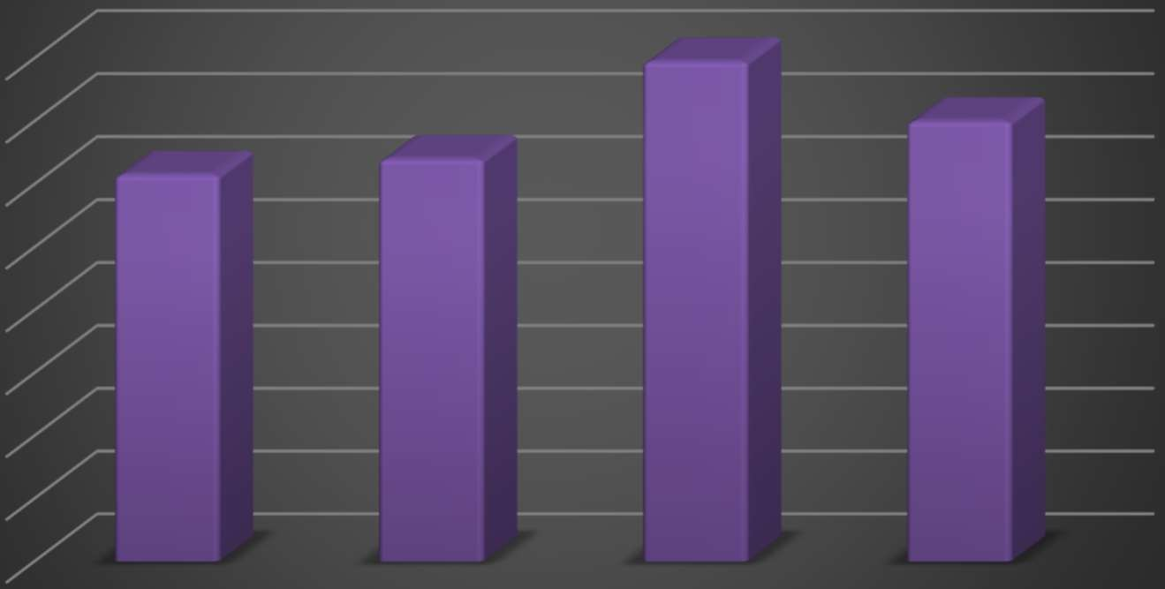

**CONTROL METHODS USAGE ANALYSIS**

160

140

120

100

80

60

40

20

0

Biocontrol

Crop Rotation

Neem Spray

Pesticide

# Percentage yield loss in every year

Shows historical impact; identifies **years with peak pest activity**.

**Pivot Table:**

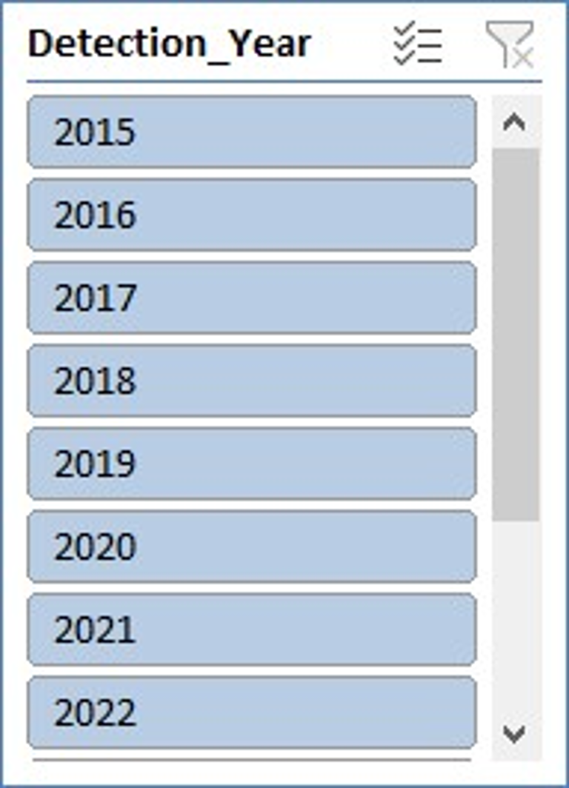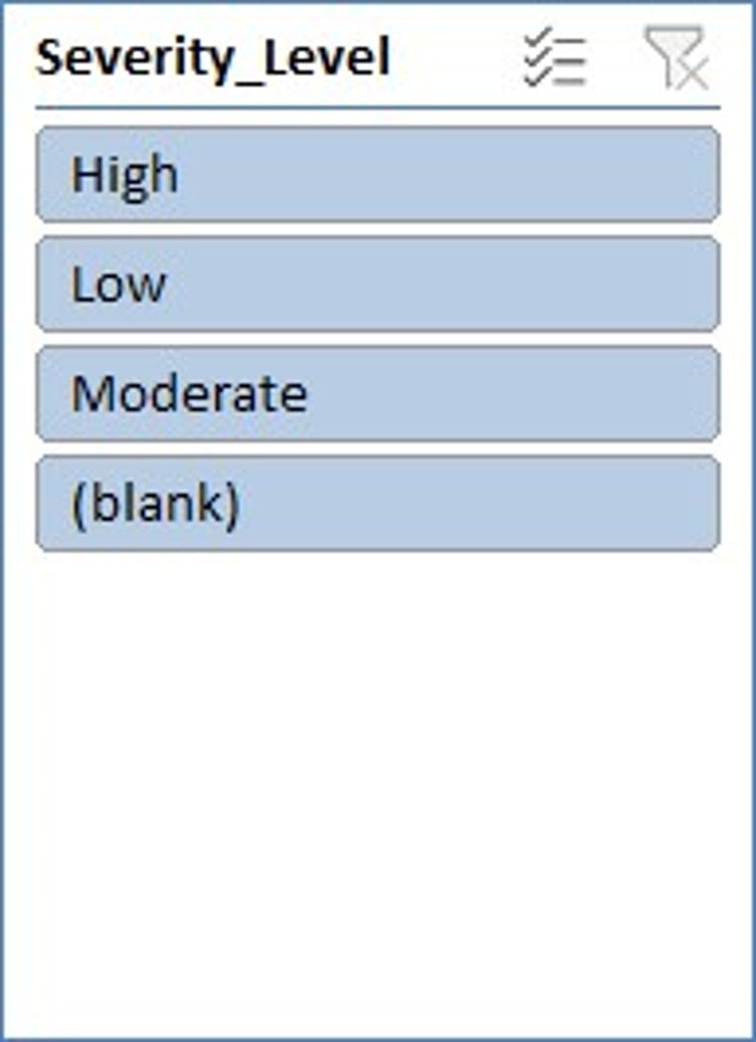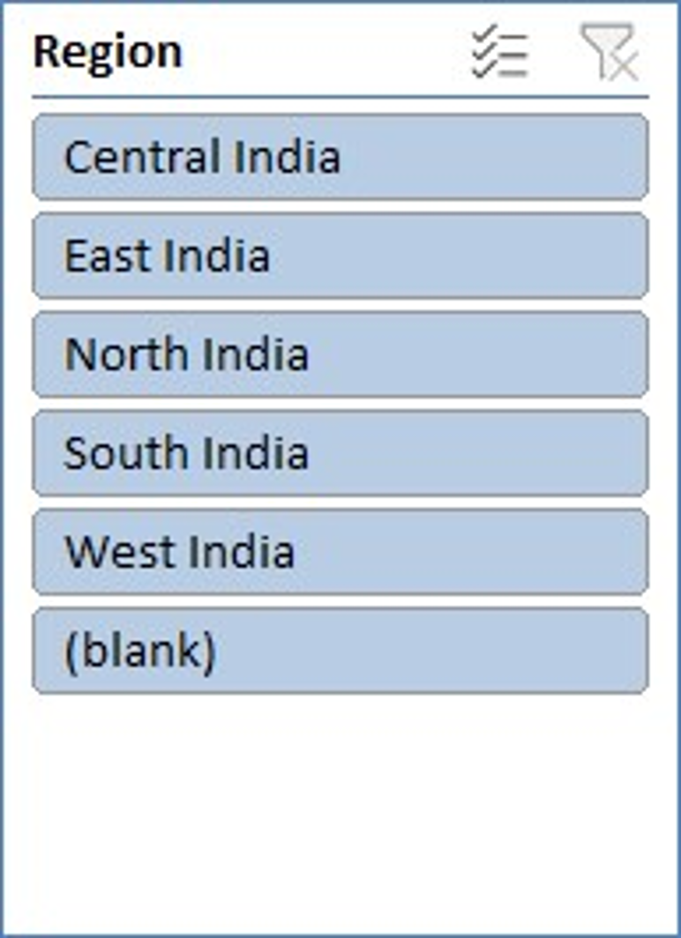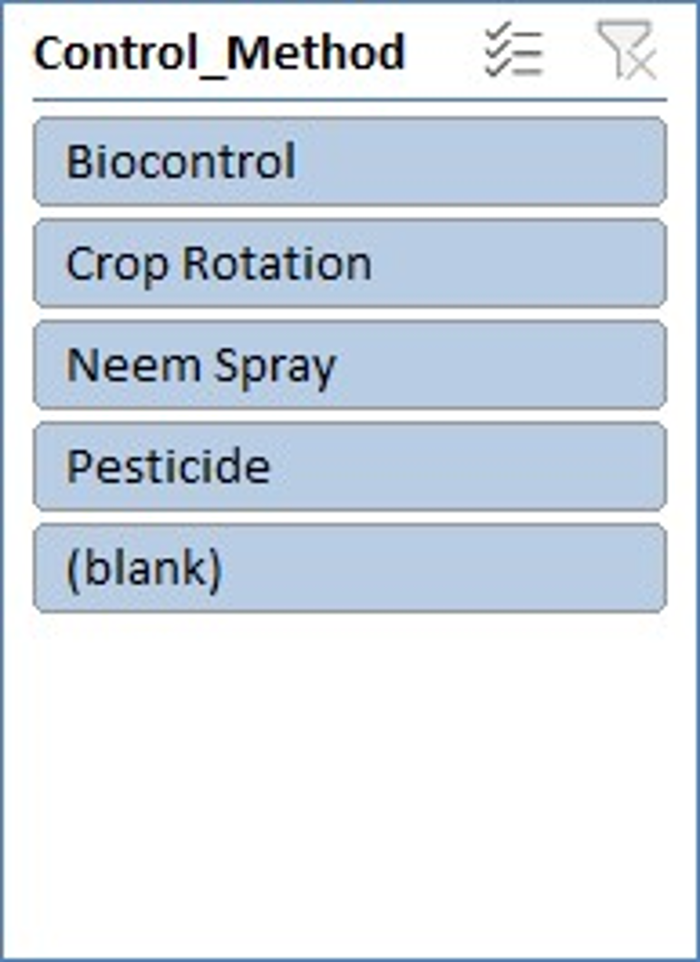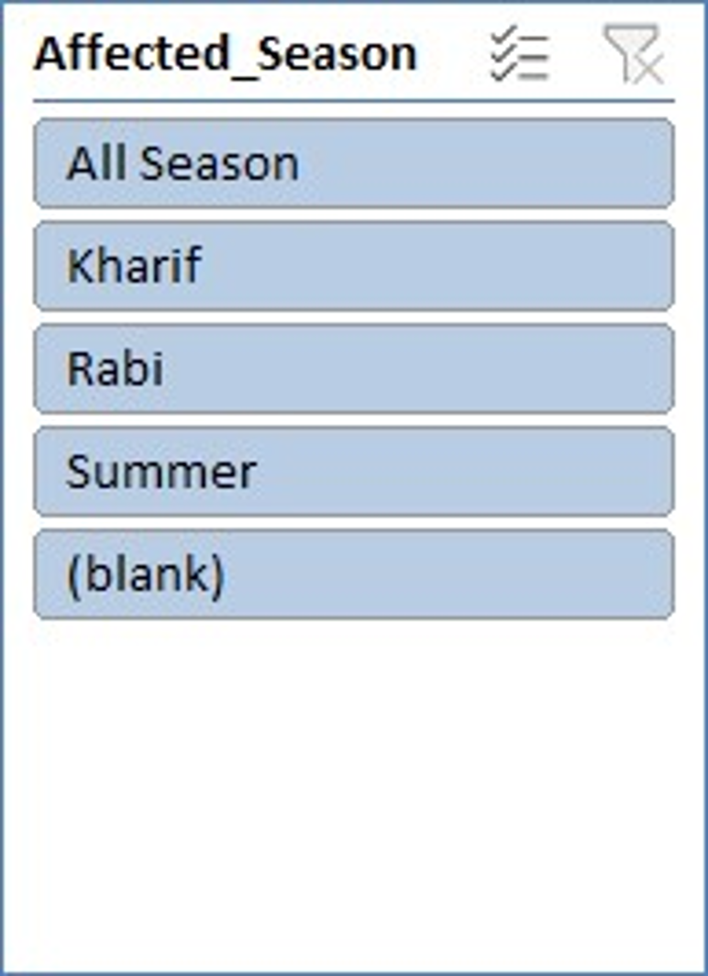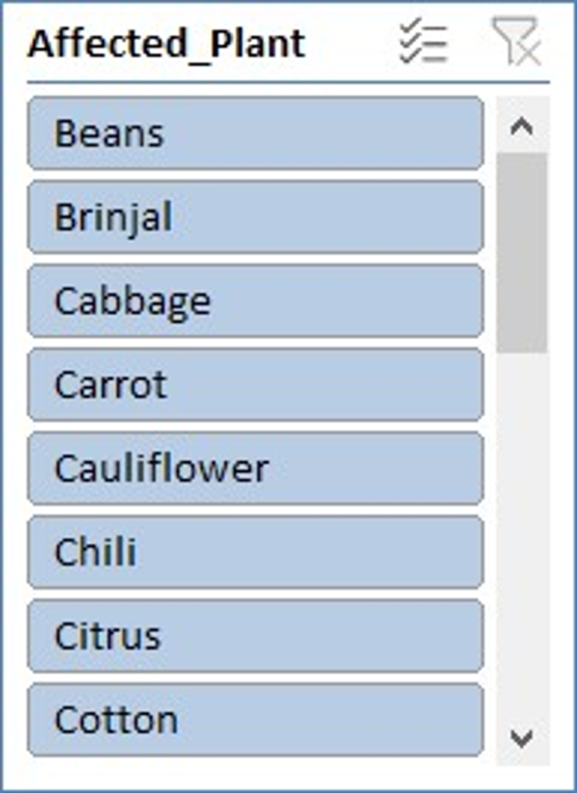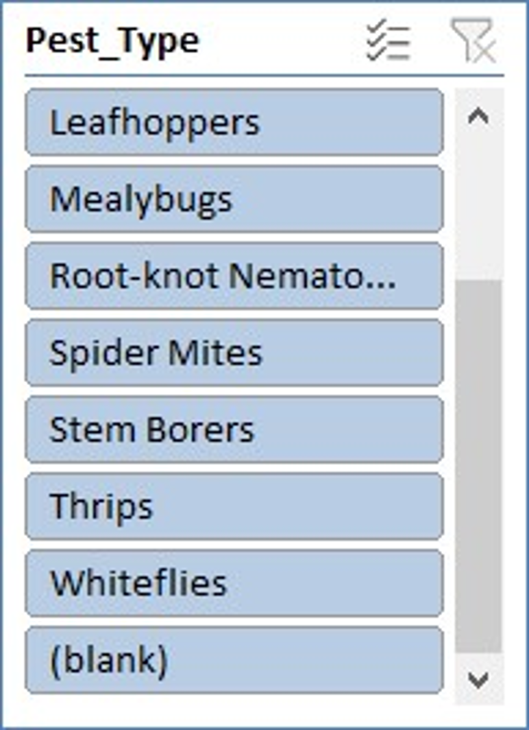

**Overall Observations**

1. **High-Impact Pests:**
   * **Fruit Flies** and **Stem Borers** cause the **highest average yield loss**, indicating their significant threat to agricultural production.
   * These pests are destructive and widespread across multiple regions and crops.
2. **Vulnerable Crops:**
   * **Guava** and **Brinjal** are frequently targeted by pests.
   * **Citrus** also shows high vulnerability, especially under Fruit Fly attacks.
3. **Seasonal Impact:**
   * **Rabi and Summer seasons** record the **highest pest-related yield losses**.
   * **All-season pests** continue to affect crops consistently throughout the year, demanding year-round monitoring.
4. **Regional Trends:**
   * **South Indian regions** appear to be more affected, possibly due to favorable climatic conditions for pest breeding.
5. **Severity Levels:**
   * Most pest cases fall under **moderate severity**.
   * This suggests the potential to control damage if detected and treated early.
6. **Control Methods Used:**
   * **Pesticides** are still widely used, but eco-friendly options like **Neem Spray** and **Biocontrol** are also popular.
   * **Crop Rotation** is practiced, but less frequent compared to direct pest control agents.
7. **Year-wise Yield Loss:**
   * Some years show a significant spike in yield loss, highlighting the need for **better preparedness** and **weather-linked pest prediction models**.

**Conclusion**

The analysis indicates that Fruit Flies and Stem Borers are major pests causing high yield losses. Guava and Citrus are frequently affected crops. South India and Rabi season see higher pest activity. Moderate severity is most common. Control methods like Neem Spray and Biocontrol are widely used.

## Recommendations

* Focus pest surveillance in Rabi and All Season periods.
* Promote eco-friendly methods like Neem Spray and Biocontrol.
* Educate farmers on identifying early signs of pest attacks.
* Regional pest control programs should be strengthened